**Edit Distance - FAQ**

**How do I tell Java to use more of my computer's memory?**

By default, Java will only use 64MB of memory (not very much for this application). You must explicitly ask for more by executing with:

java -Xmx300m EditDistance < input.txt

The **300m** means 300MB, and you should adjust this number depending on the amount of memory your computer has and the size of the arrays you will need for the data set you are running. (Everyone should be able to request 300m which should get you through "ecoli7000.txt". If your computer has sufficient memory, you can request 600m which should handle "ecoli10000.txt".)

If you're running your program through Eclipse (not the command line), you can pass in virtual machine (VM) arguments by going to Run -> Run configurations -> Arguments -> VM arguments.

**How do I determine how much memory my computer has available?**

Google it.

**Can I assume that the input characters will always be A, C, G or T?**

No, your program should work equally well for any letter, upper case or lower case.

**I forget, how do I declare and initialize a two dimensional array in Java?**

Use int[][] opt = new int[M+1][N+1]; for an (M+1)-by-(N+1) array. All entries are initialized to 0.

**How exactly does this problem have optimal sub-structure (overlapping sub-problems)?**

Here's a nice graphic from Geeks for Geeks:

[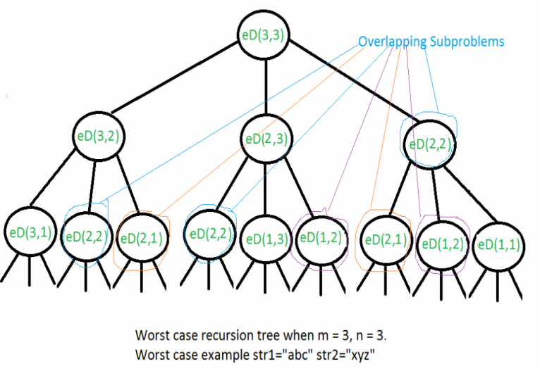](https://www.geeksforgeeks.org/wp-content/uploads/EditDistance.png)

**It seems strange to define x[i..M] to be the substring consisting of x[i] through x[M-1] instead of x[i] through x[M]. Is this a typo?**

It's a little strange, but no, it's not a typo. It's consistent with Java's indexing notation where the left endpoint is inclusive and the right endpoint is exclusive.

This corresponds exactly with x.substring(i, M) in Java. However, you shouldn't need to use the substring method on this assignment.

**Which alignment should I print out if there are two or more optimal ones?**

Output any one you like. Follow your *heart.*